The Thing Network
Kurz: Open Source IoT Netzwerk auf 868Mhz / 433Mhz
Kickstarter: https://www.kickstarter.com/projects/419277966/the-things-network/description
Webseite: http://thethingsnetwork.org/
Forum: http://forum.thethingsnetwork.org

Wie baut man einen Node?
Auf Basis eines
- Arduino Nano
- RFM95 / RFM95W
- Sensor
Anleitungen:
- Verkabeln: https://things4u.github.io/HardwareGuide/Arduino/Mini-Sensor-HTU21/mini-lowpower.html
- Code: https://github.com/things4u/LoRa-Thing
- Code / Anleitung für TTN Setup: https://github.com/lukastheiler/ttn_moteino
- http://staging.thethingsnetwork.org/wiki/Backend/ttnctl/QuickStart

Wie baut man einen Single Channel Gateway?
Ein Single Channel Gateway kann nur 1 Channel von 8 Channel benutzen.
Ein Single Channel Gateway kann keine Daten an die Nodes schicken.
Auf Basis von:
- Pi B / Pi Zero
- Alternativ: Esp8266 (NodeMCU / Wemos)
- RFM95 / RFM95W
- Lan / Wlan
Anleitung:
- Pi: http://things4u.github.io/HardwareGuide/Single-Channel-Gway/index.html
- Pi: Code und Verkabelung: https://github.com/tftelkamp/single_chan_pkt_fwd
- Pi Zero PCB: https://oshpark.com/shared_projects/36EsiJqR
- Esp Anleitung: http://things4u.github.io/HardwareGuide/Single-Channel-Gway/ESP-Gateway.html
- TTN Forum: http://forum.thethingsnetwork.org/t/single-channel-gateway/798

TheThingsNetwork Node/Sensor Workshop
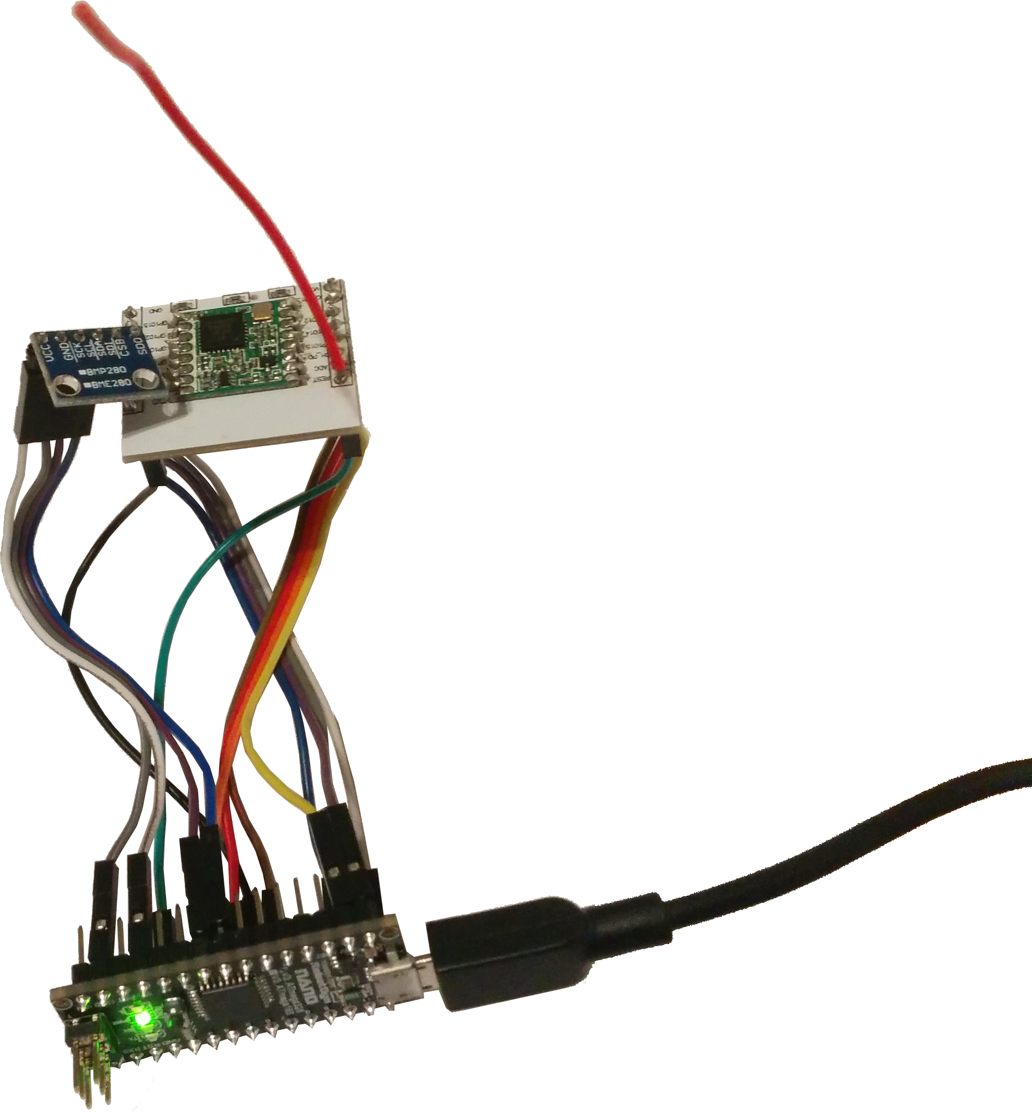

Materialliste
Artikel | Menge | Preis | Link
Arduino 328 Nano Micro USB (tested) | 10x | ~1,88/St. | http://www.aliexpress.com/item/Nano-CH340-ATmega328P-MicroUSB-Compatible-for-Arduino-Nano-V3/32572612009.html
oder MassDuino-UNO (untested) | 10x | ~2,99/St. | http://de.aliexpress.com/item/MassDuino-UNO-LC-MD-328D-R3-5V-3-3V-Development-Board-for-Arduino-Compatible-Low-Cost/32655296623.html
RFM95/RFM95W | 10x | ~16,00/2St. | http://www.aliexpress.com/item/RFM95W-RFM98W-100mW-433-868-915Mhz-High-sensitivity-sx1278-sx1276-Lora-module-ultra-long-range-RF/32626274785.html
Sensor Kit | 10x | ~11,95/37St | http://www.aliexpress.com/item/37-IN-1-SENSOR-KITS-FOR-ARDUINO-HIGH-QUALITY-FREE-SHIPPING-Works-with-Official-for-Arduino/32542655411.html
Kabel | 100x | ~2,60/120St | http://de.aliexpress.com/item/Dupont-line-120pcs-20cm-male-to-male-male-to-female-and-female-to-female-jumper-wire/32551814663.html
Adapter PCB | 10x | ~2,58/10St | http://nl.aliexpress.com/store/product/10pcs-lot-ESP8266-serial-WIFI-module-connecting-plate-applicable-to-ESP-07-the-ESP-08-ESP/403088_32262406988.html?storeId=403088
Optional:
Artikel | Menge | Preis | Link
Antenne | 10x | ~1,70/St.
SMA | 10x | ~1,95/10St. | http://de.aliexpress.com/item/10pcs-SMA-Female-Jack-Solder-Edge-PCB-Mount-Straight-RF-Connector/32429747943.html

ToDo
- Materialliste prüfen!
- Passt die SMA Buchse?

TheThingsNetwork Gateway Workshop

Materialliste
Artikel | Menge | Preis | Link
Pi | 10x | ~20,00/St. | bring ur own
RFM95/RFM95W | 10x | ~16,00/2St. | http://www.aliexpress.com/item/RFM95W-RFM98W-100mW-433-868-915Mhz-High-sensitivity-sx1278-sx1276-Lora-module-ultra-long-range-RF/32626274785.html
PCB | 10x | ~23,80/10St | https://oshpark.com/shared_projects/36EsiJqR
oder
Artikel | Menge | Preis | Link
Pi | 10x | ~20,00/St. | bring ur own
RFM95/RFM95W | 10x | ~16,00/2St. | http://www.aliexpress.com/item/RFM95W-RFM98W-100mW-433-868-915Mhz-High-sensitivity-sx1278-sx1276-Lora-module-ultra-long-range-RF/32626274785.html
ugly PCB | 10x | ~2,58/10St | http://nl.aliexpress.com/store/product/10pcs-lot-ESP8266-serial-WIFI-module-connecting-plate-applicable-to-ESP-07-the-ESP-08-ESP/403088_32262406988.html?storeId=403088
Kabel | 100x | ~2,60/120St | http://de.aliexpress.com/item/Dupont-line-120pcs-20cm-male-to-male-male-to-female-and-female-to-female-jumper-wire/32551814663.html
oder
Artikel | Menge | Preis | Link
Wemos | 10x | ~2,60/St. | http://de.aliexpress.com/item/Smart-Electronics-D1-mini-Mini-NodeMcu-4M-bytes-Lua-WIFI-Internet-of-Things-development-board-based/32630067955.html
RFM95/RFM95W | 10x | ~16,00/2St. | http://www.aliexpress.com/item/RFM95W-RFM98W-100mW-433-868-915Mhz-High-sensitivity-sx1278-sx1276-Lora-module-ultra-long-range-RF/32626274785.html
ugly PCB | 10x | ~2,58/10St | http://nl.aliexpress.com/store/product/10pcs-lot-ESP8266-serial-WIFI-module-connecting-plate-applicable-to-ESP-07-the-ESP-08-ESP/403088_32262406988.html?storeId=403088
Kabel | 100x | ~2,60/120St | http://de.aliexpress.com/item/Dupont-line-120pcs-20cm-male-to-male-male-to-female-and-female-to-female-jumper-wire/32551814663.html
Optional:
Artikel | Menge | Preis | Link
Antenne | 10x | ~1,70/St.
SMA | 10x | ~1,95/10St. | http://de.aliexpress.com/item/10pcs-SMA-Female-Jack-Solder-Edge-PCB-Mount-Straight-RF-Connector/32429747943.html

ToDo
- Materialliste prüfen!
- Oder wäre eine Dual Channel Gateway Workshop besser?
  - https://store.uputronics.com/index.php?route=product/product&product_id=68
  - https://github.com/bokse001/dual_chan_pkt_fwd
- Sind 20cm Kabel zu lang?
- Wie wäre ein https://github.com/hallard/WeMos-Lora ?

